MEMORANDUM #2

TO: Design Teams, Chemical Processes Division
FROM: Kenneth R. Cox, Vice President of Engineering
DATE: September 30, 2005
SUBJECT: Acetone Plant Design—Change in Scope

A meeting by Rice Universal Pharmaceuticals (Rice UP) was held earlier this week to update Serendipity on their strategic outlook in the inner-ear pharmaceutical market. Marketing research confirms that, with very little risk, demand warrants an Anphal production increase requiring a 30% rate increase above the acetone plant’s original nameplate capacity. When Rice UP inquired whether this was possible, Serendipity’s management apologized that an answer was not yet finalized. They stressed that the design teams are working overtime and promised resolution within the next week.

Rice UP described their commitment to increasing Anphal production and therefore their need for FDA-approved acetone, regardless of supply source or method. Further refining their expectations, they emphasized that their primary goal is to pursue the lowest cost option for obtaining 39 MM lb acetone. This includes consideration of additional equipment purchases and modification of existing equipment and piping. Potentially, purchasing FDA-approved acetone from the open market to supplement the current plant’s maximum capacity is a competitive option. Whatever the solution, Rice UP needs an official recommendation by mid-December. To meet this deadline, Serendipity has set an internal cut-off date of October 20 for final design report submittals, with formal oral presentations also scheduled for October 20.

Revised Project Scope
Based on Rice UP’s willingness to authorize additional capital purchases if necessary, maximum design flexibility is now at your disposal. Obviously, the first step is to determine whether the existing design has sufficient overdesign to support the 30% acetone rate increase. If not, the next step is limited only by your team’s creativity and imagination. Before embarking on alternative scenario comparisons, however, keep in mind that insufficient time exists to test an infinite number of options. At this point, identifying a team methodology for brainstorming and testing case studies is crucial to efficient time usage. How will ideas be prioritized and tested? What key variables should be focused upon for first-pass acceptance/rejection prior to detailed simulation? What are individual team members’ responsibilities?

Process considerations should include asking (but are not limited to): What is the optimum distribution of acetone supply between plant production and purchasing it on the open market (i.e. 30:9, 35:4, 39:0 [MMlb:MMlb])? Can keeping the same hardware but changing the flowsheet arrangement/order (by rerouting pipes) obtain more capacity from the plant? Would a change in operating temperatures or pressures be advantageous? Are there better feed tray locations in the existing columns? Using the existing columns, would packing be better than plates? Is there an alternative separation method to distillation? Should one big, new column replace an existing column, or can a smaller “helper” column be piggy-backed to an existing unit?

Economics
The following equation should be used as your economic comparison basis between alternatives:

$$\text{TAC}=\left(2\text{.}{\text{43K}}_{\text{capital}}+0\text{.}\text{19}\right)C_{\text{capital}}+C_{\text{operating}}$$

where TAC = total annual cost [$], K_{capital} = capital charge factor which accounts for the time value of money (assume ¼ [year⁻¹]), C_{capital} = total installed capital cost of equipment [$], and C_{operating} = sum of heating/cooling costs, penalty for waste disposal, and the difference between the products and raw materials [$]. Regardless of design scenario (i.e. with or without purchasing new equipment), C_{operating} will always be considered. If additional acetone will be purchased from the open market, it should be included as an expense for C_{operating}. The application of C_{capital} will depend upon the magnitude of equipment modification. Juggling the order of unit operations or changing sources of utility streams involves (relatively) minor costs such as redirecting pipe, resizing control valves, and rearranging placement of pumps. Similarly, cost of feed tray relocation in an existing column is small. For these situations, assume this cost is covered by the current installation’s contingency budget, therefore C_{capital} = $0. All other costs to be considered, such as new equipment purchase (e.g. columns, heat exchangers, etc.) and retrofit of existing equipment (e.g. replacing column trays with packing), represent major factors that must be included in a nonzero C_{capital}. If there is doubt concerning proper cost accounting rules or additional equations are needed to estimate costs for new equipment other than exchangers and columns, consult Serendipity’s as-yet-unindicted accounting department for advice.

Advice on utility and feedstock prices will be issued shortly by our office.

As far as determining whether trays or packing is better for a column, refer to the heuristic (attached) for rule of thumb guidance.

Two different methods are available to simulate columns on HYSYS, either by using its standard “column block” or by adding each condenser, reboiler, and pump individually. For groups using the “column block,” you should realize that HYSYS does not include pumps nor heat exchangers. Instead, it uses heaters and coolers to calculate energy requirements (which are simply mass and energy balances) that do not consider UA limitations, and it gives no pump electricity usage at all. For the condensers and reboilers, you will have to perform separate (spreadsheet?) calculations based on their calculated heat duties to estimate required utility flows. Recall that the cooling and refrigerated water systems have upper temperature limits on their return streams. For overheads and bottoms pumps, either create a self-standing pump with feed stream defined from the respective distillation column, or take the energy equation from the HYSYS documentation and calculate the energy usage yourself. For the 2nd option, follow these steps to find the equation:
- Start Menu → Programs → Simulation Software → HYSYS Plant 2.2 → Menu.pdf to open HYSYS Documentation Suite.
- Click on HYSYS.Plant 2.2 hyperlink to open HYSYS.Plant 2.2 Documentation.
- Click on Steady-State Modeling hyperlink to open the Table of Contents.
- Click on hyperlinked page reference “5-16” for Section 5.2: Pump.
- There are 2 pages of theory and equations.
Estimating cost of heat exchangers:
Doherty, M.F., and Malone, M.F. Conceptual Design of Distillation Systems. McGraw: Boston (2001). [attached]

NOTE: Doherty uses the Marshall and Swift price index!

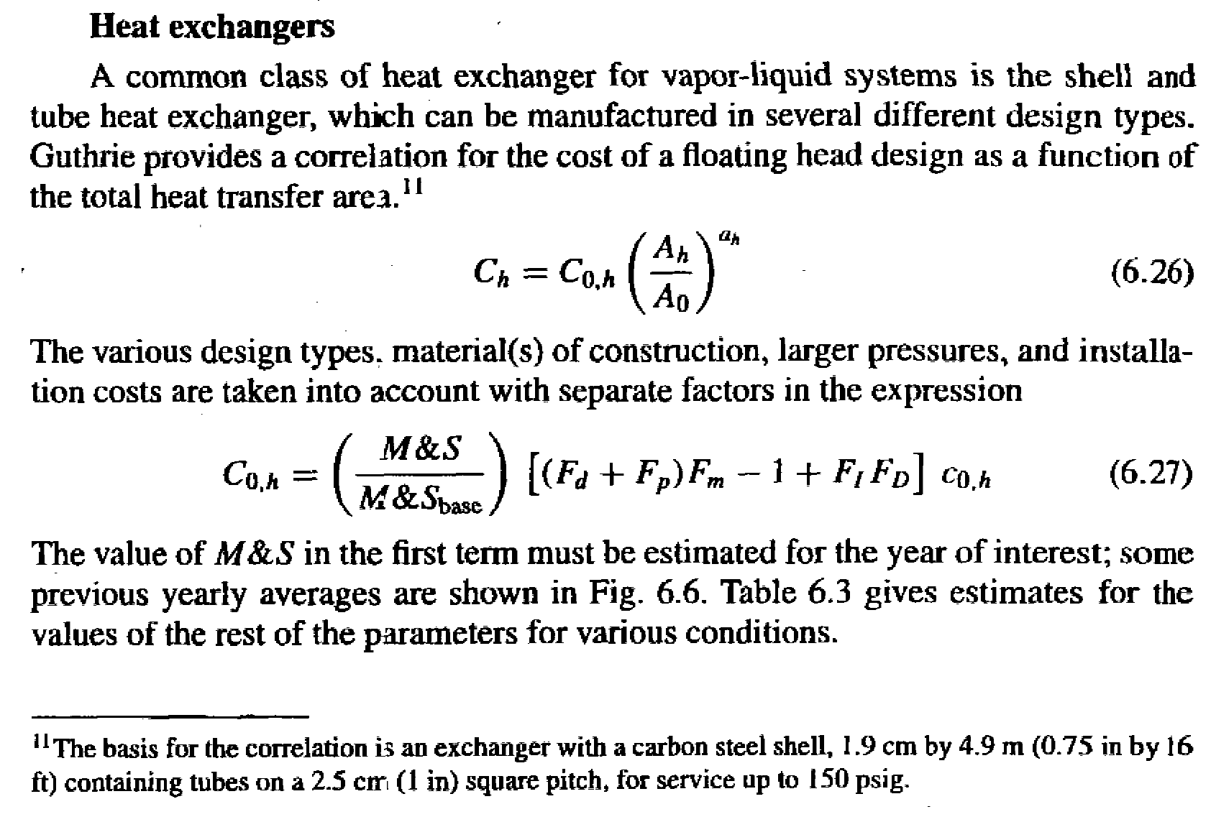
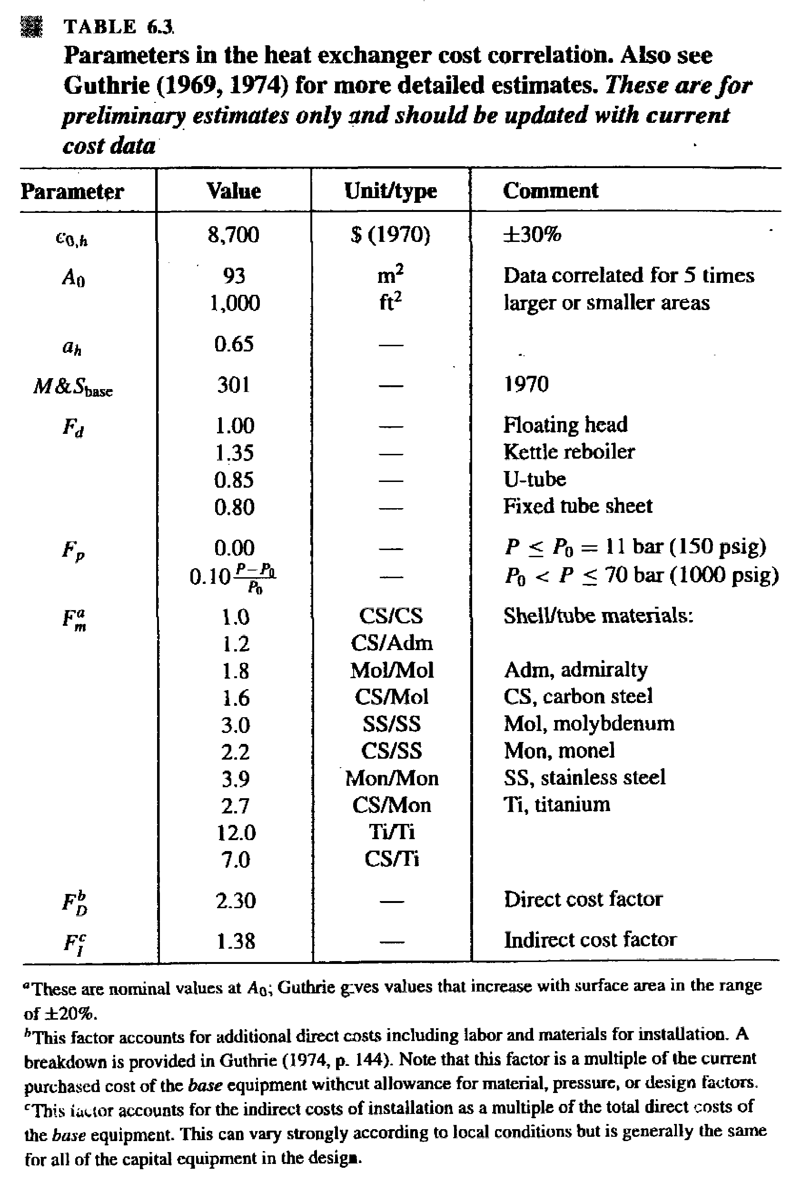
Estimating cost of distillation columns:
Ulrich, G.D. A Guide to Chemical Engineering Design and Economics. Wiley: New York (1984). [attached]

NOTE: Ulrich uses the Chemical Engineering plant cost index!

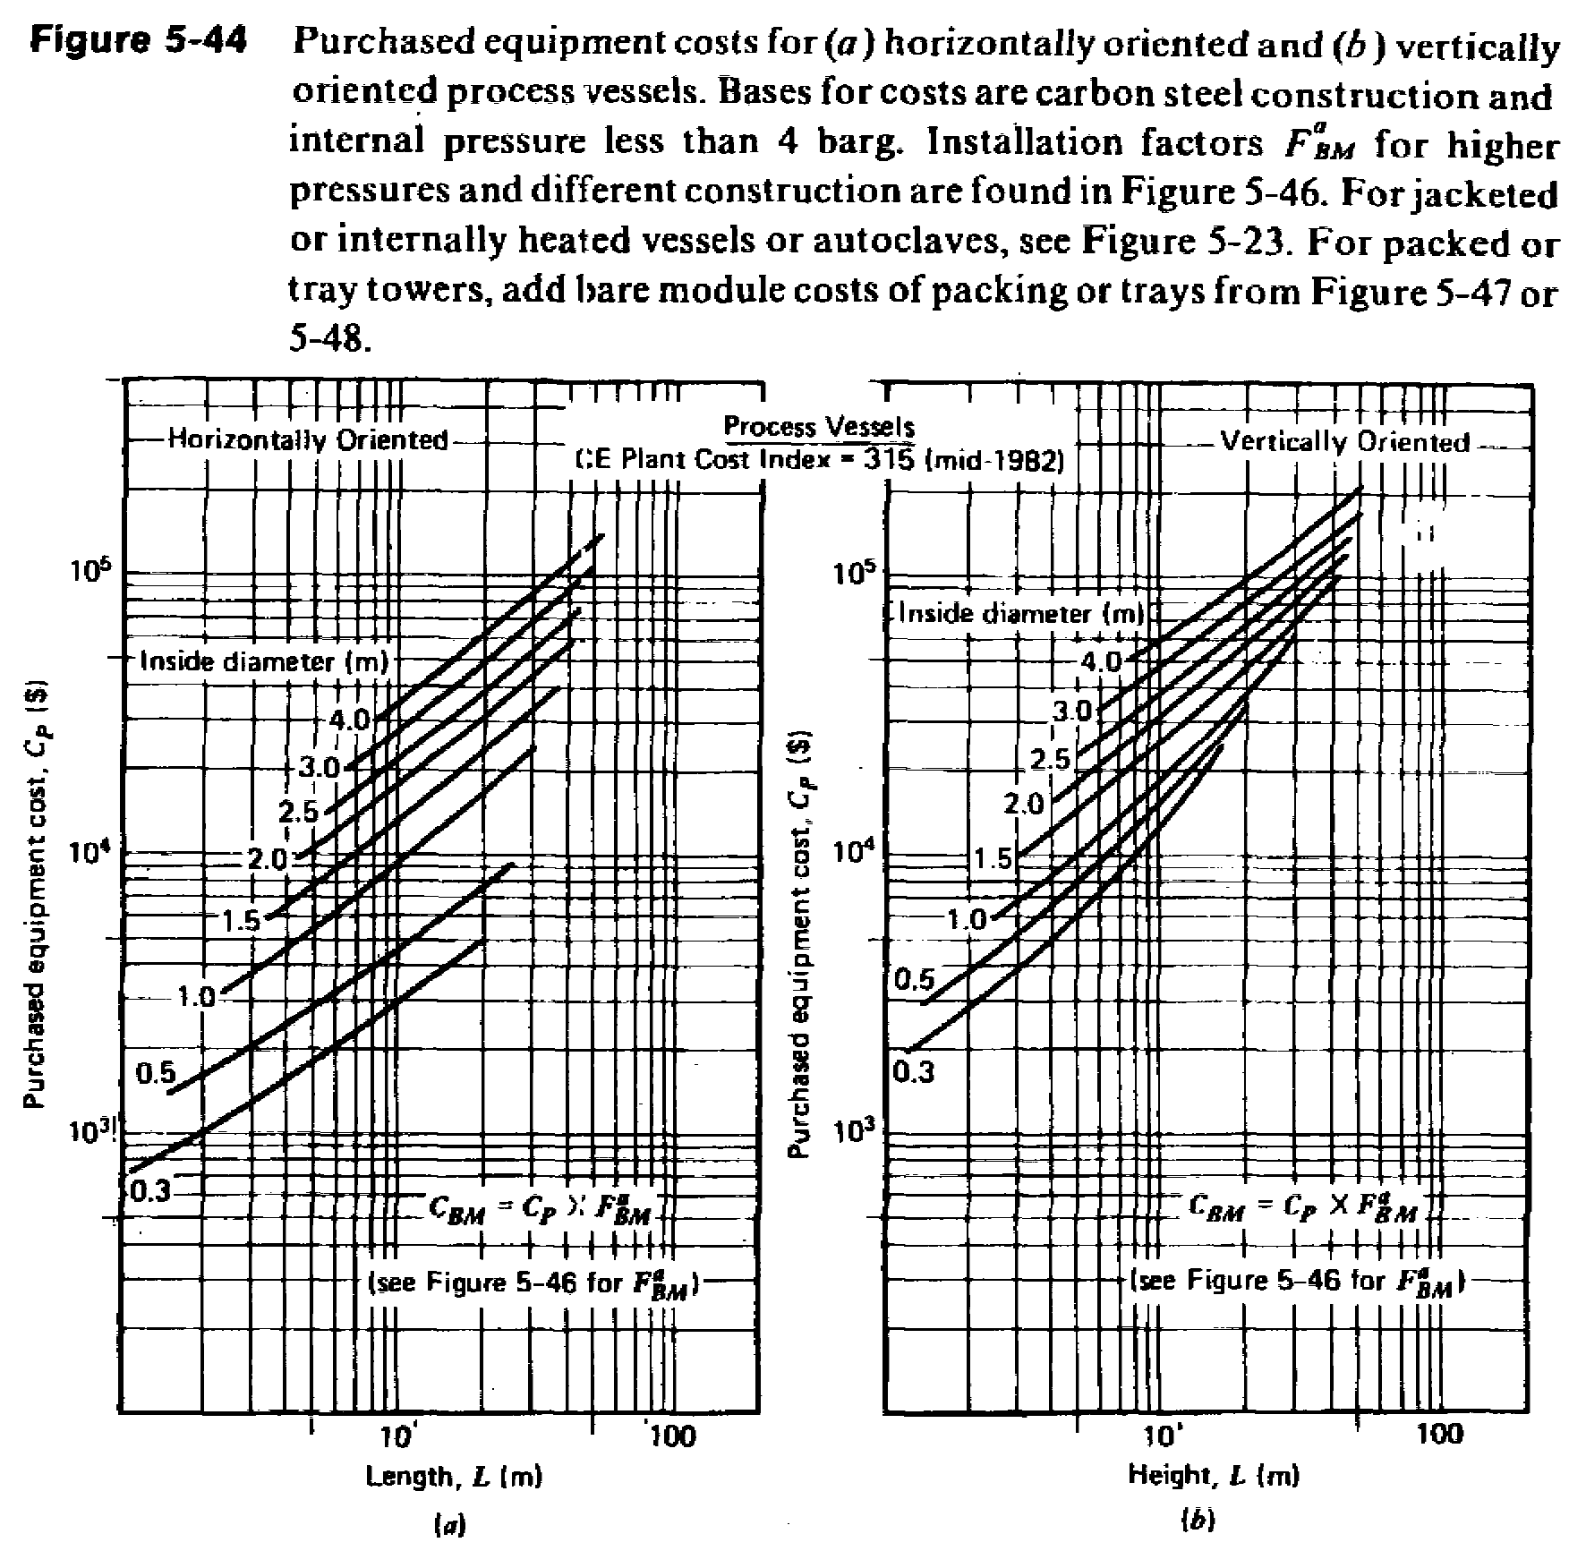

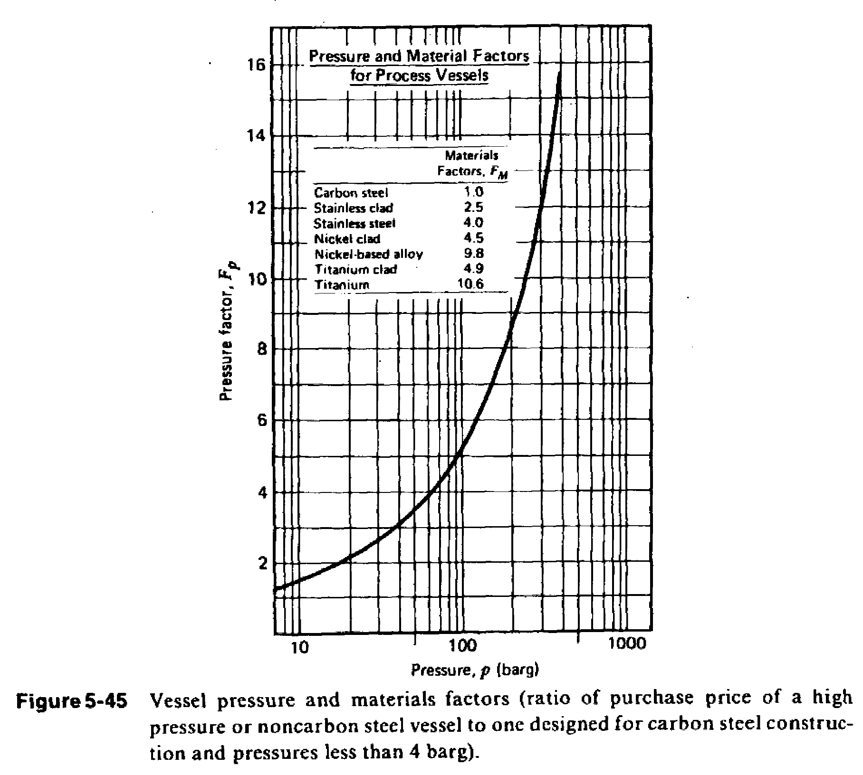

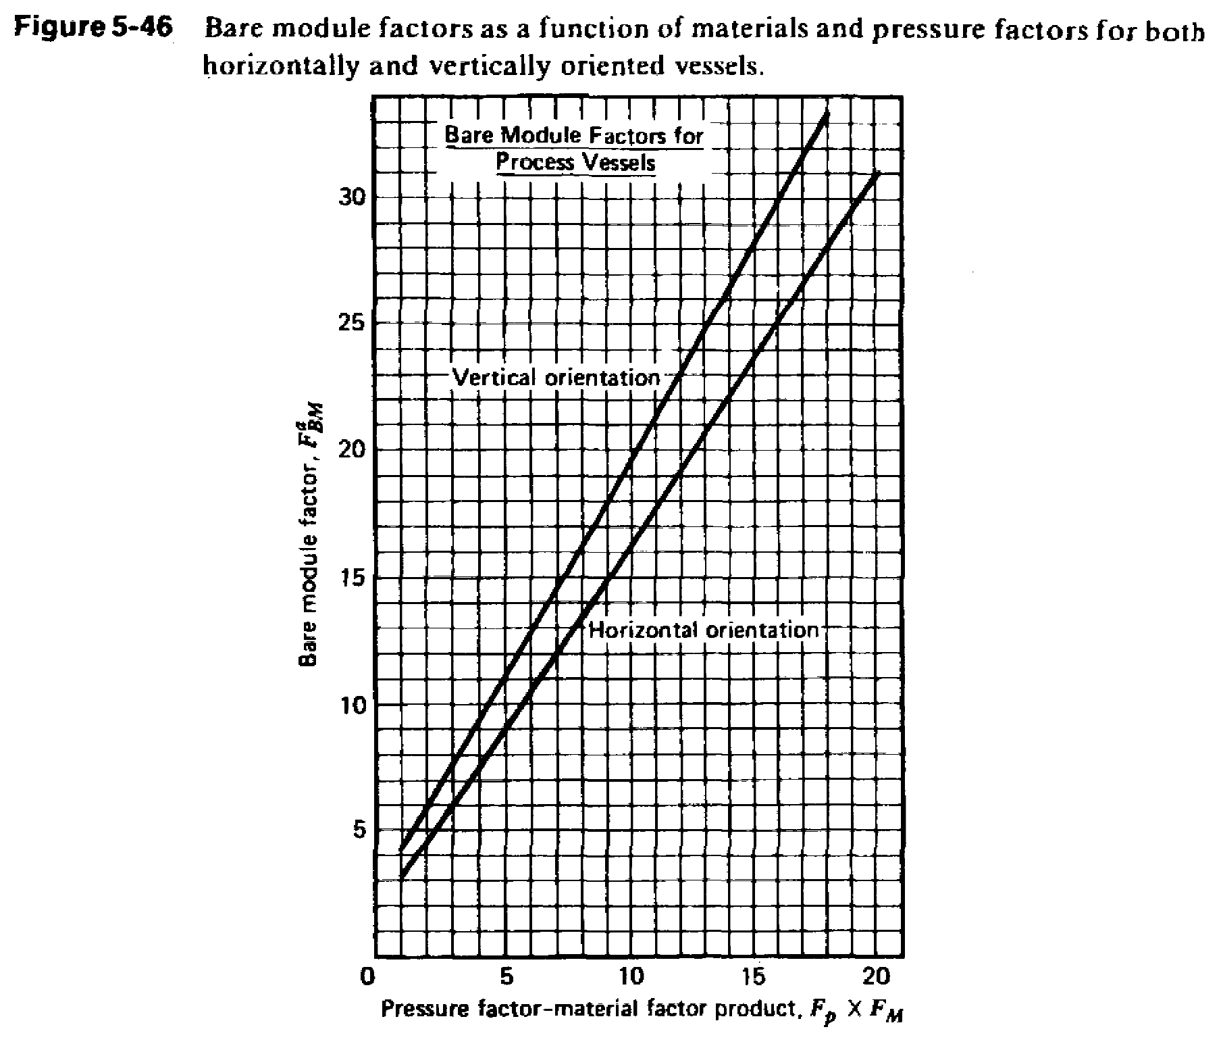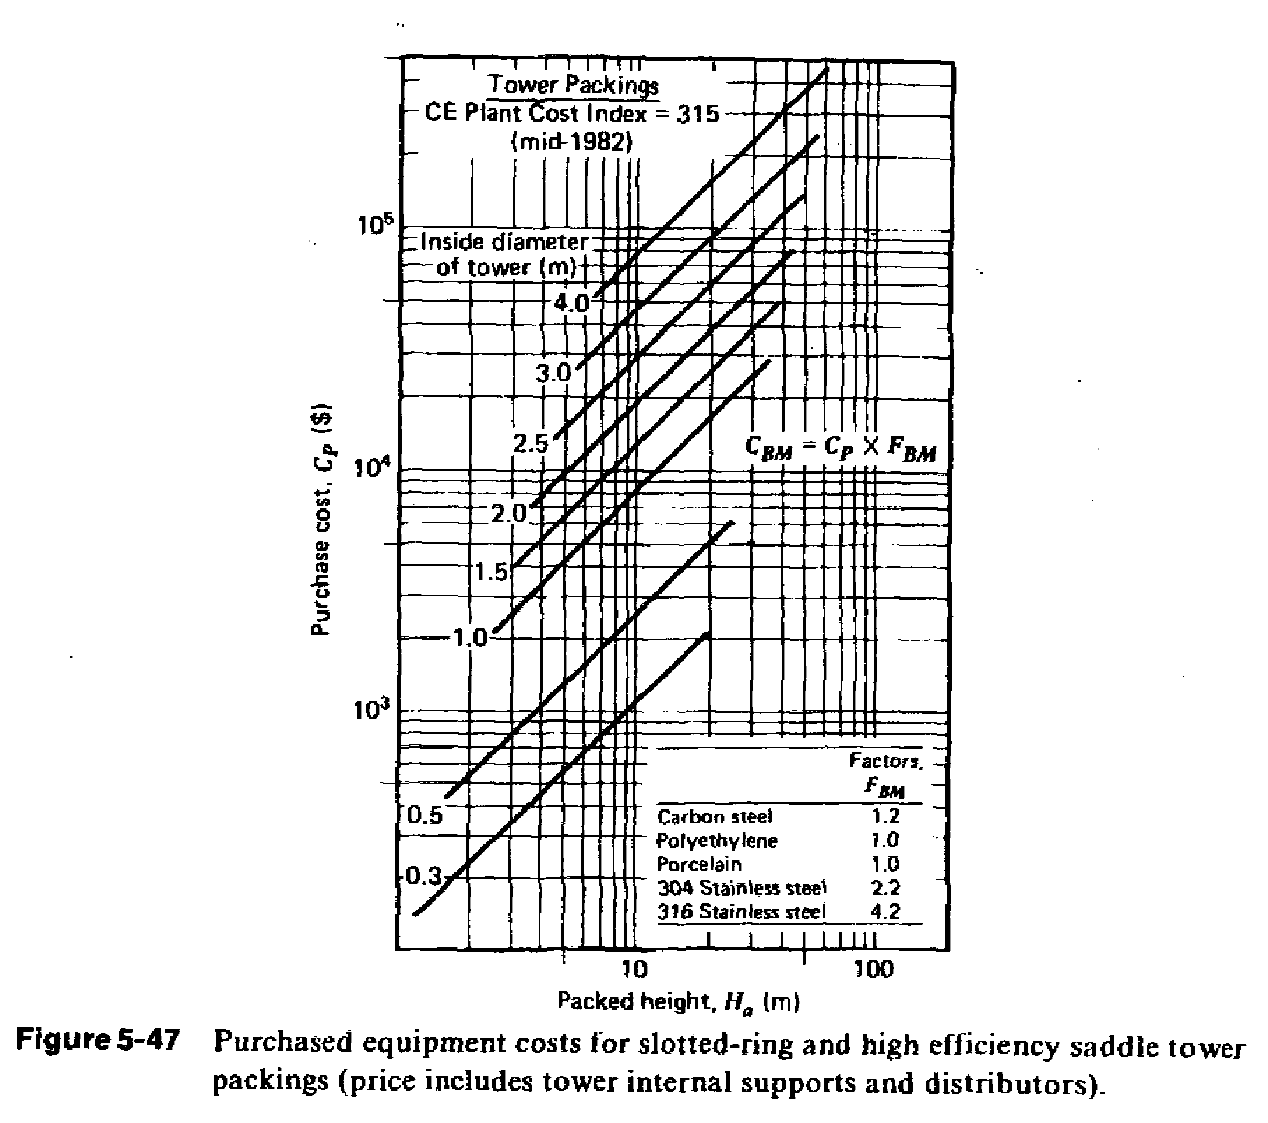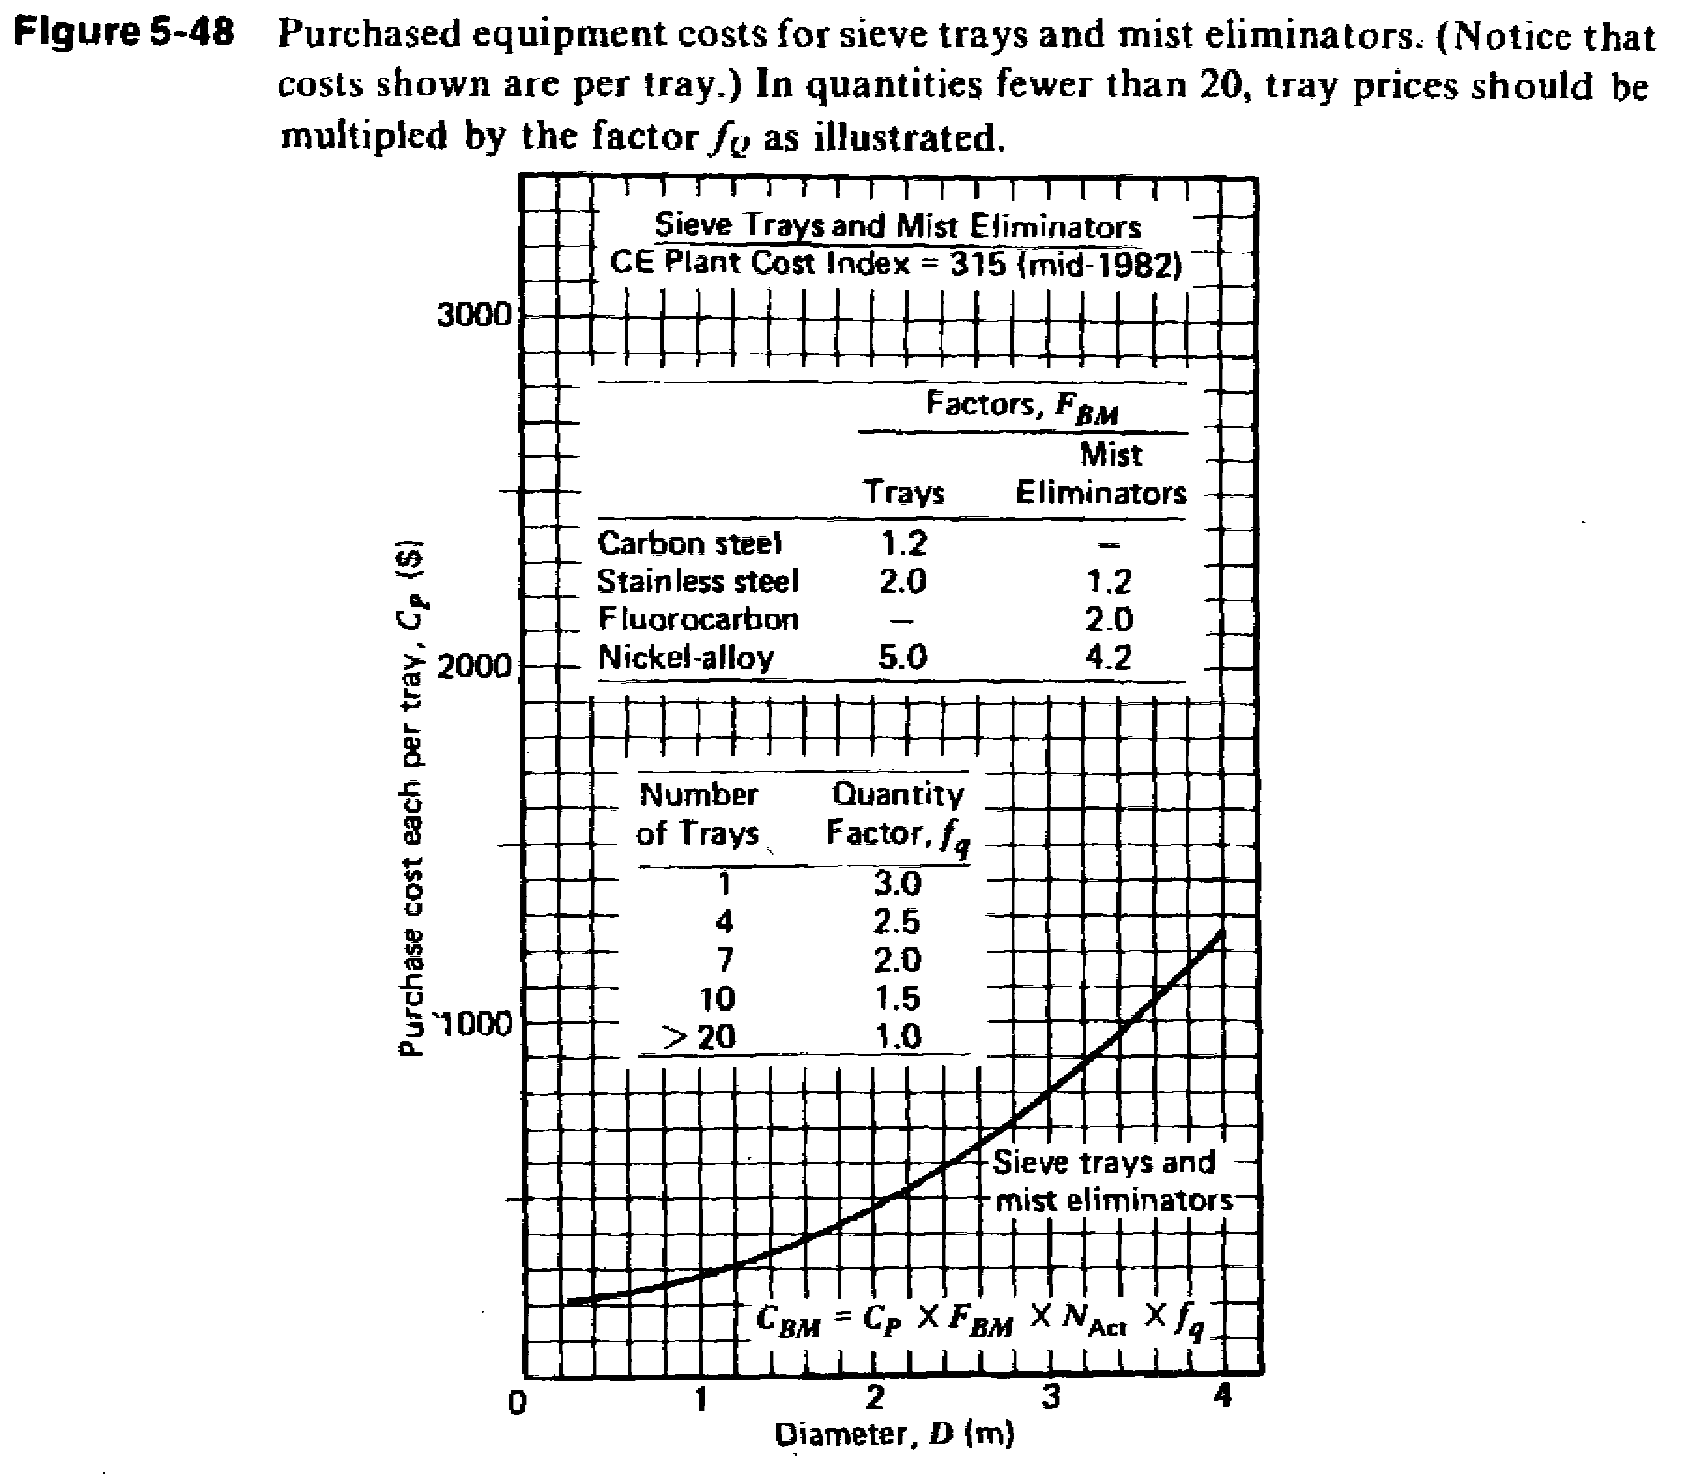
Peters, M.S., and Timmerhaus, K.D. Plant Design and Economics for Chemical Engineers, 4th ed.. McGraw: Boston (1991).

RELATIVE MERITS OF PLATE AND PACKED TOWERS

- Stage efficiencies for packed towers must be based on experimental tests with each type of packing. The efficiency varies, not only with the type and of packing, but also with the fluid rates, the fluid properties, the column diameter, the operating pressure, and, in general, the extent of liquid dispersion over the available packing surface.
- Because of liquid-dispersion difficulties in packed towers, the design of plate towers is considerably more reliable and requires less safety factor when the ratio of liquid mass velocity to gas mass velocity is low.
- Plate towers can be designed to handle wide ranges of liquid rates without flooding.
- If the operation involves liquids that contain dispersed solids, use of a plate tower is preferred because the plates are more accessible for cleaning.
- Plate towers are preferred if interstage cooling is required to remove heats of reaction or solution, because cooling coils can be installed on the plates or the liquid-delivery line from plate to plate can be passed through an external cooler.
- The total weight of a dry plate tower is usually less than that of a packed tower designed for the same duty. However, if liquid holdup during operation is taken into account, both types of towers have about the same weight.
- When large temperature changes are involved, as in distillation operations, plate towers are often preferred because thermal expansion or contraction of the equipment components may crush the packing.
- Design information for plate towers is generally more readily available and more reliable than that for packed towers.
- Random-packed towers are seldom designed with diameters larger than 4 ft, and diameters of commercial plate towers are seldom less than 2 ft.
- Packed towers prove to be cheaper and easier to construct than plate towers if highly corrosive fluids must be handled.
- Packed towers are usually preferred if the liquids have a large tendency to foam.
- The amount of liquid holdup is considerably less in packed towers.
- The pressure drop through packed towers may be less than the pressure drop through plate towers designed for the same duty. This advantage, plus the fact that the packing serves to lessen the possibility of tower-wall collapse, makes packed towers particularly desirable for vacuum operation.

