
Problems with MECH 407/408 Design Reports
Revised July 30, 2026
The design reports in MECH 407/408 are intended to be challenging. They are, after all, the culmination of your Rice experience. This resource describes some of the problems typically encountered by students as they produce their reports. The examples given are from an actual report submitted for MECH 407. For background information on the common format and structure for this type of report, see the Cain Project resource “MECH 408 Spring Design Report Assignment.”

The most common problems that occur in producing a design report are as follows:

- Failing to provide context, background, or justification for the data obtained, choices made, or designs presented
- Organizing the document chronologically, resulting in a report that focuses on what you did rather than on the results and your analysis of the design choices made
- Failing to use diagrams, figures, calculations, and references to support arguments
- Using informal language or qualitative descriptions that undermine your credibility

In the sections below, you will find annotated examples of student writing and explanations for how to avoid these problems in your report.

Example #1: Failing to Provide Context, Background, or Justification
In your university training, you complete projects because you have to. Projects are assigned by an instructor, tasks are usually straightforward, and your job is simply to prove that you have done the work and achieved the results the instructor expects.

In a design course—and in the real world—projects will not be this straightforward. Reports, as a result, must explain why a project is worth doing. They must also put your work in context with past work, which proves your credibility while providing further justification for your work.

Such background information is typically found in an introduction. Consider this section your opportunity to explain why your problem is important, how others have approached it, and the requirements associated with it. Try to think about the questions your reader will ask. And write in such a way to convince a skeptical reader of your project’s value.

Below is an example of an opening section from a student paper. It has been annotated to illustrate some of the problems with it. Some possible solutions are also given.

Student Example

PART I: Introduction

1.1 Problem Statement
Inverted pendulums are a classic controls problem that is well understood in the engineering world. In the simplest of cases, a rod standing straight up is pinned to a cart. The rod can freely rotate in one plane perpendicular to the ground, and the cart can input a force in the line that is parallel to the ground and inside the rotation plane. By simply knowing the tilt of the rod, the cart can drive at the necessary speed so that the rod becomes vertical again. An interesting application of this inverted pendulum would be to make it so that the rod could fall in any direction and create a cart that could balance this rod.
While few two dimensional inverted pendulums have been built, all are purely for research purposes only, and none have much practical application. These devices have some limit as to how far they can go in either one or both directions. This group has decided to create an inverted pendulum that can move in any direction with no restrictions on distance traveled. This device has a few potential applications such as of omni-directional drive system for a robot or possibly an improvement on the current Segway which is a scooter that uses the control theory for an inverted pendulum to transport people.
The goal of this project is as follows: create an autonomous two-dimensional inverted pendulum that is stable and can stay balanced at all times with no need for human interaction. A secondary goal is to build it so that it can transport a human. The major engineering aspects of the design problem are modeling of the entire system, design of the drive system, sensing of the device states, and the programming of the control system to control the inverted pendulum system.

Analysis
In its introduction, the team is trying to cover too much ground. You can’t get to a problem statement without providing background information on the problem you are solving, why it is important to solve, and how others have solved it.
A better organization of this section would have begun with a discussion of the gold standard in inverted pendulums: How the concept works in theory and how it has been implemented in practice. The next paragraph(s) would discuss the drawbacks of the gold standard and ways others have tried to improve on it. After that, the team would introduce the holy grail: The concept of a 2D inverted pendulum, the potential benefits of this approach, and the specific requirements necessary to achieve it. The section would then end with this team’s specific proposal. “We plan to design a 2-DOF inverted pendulum like the Segway that improves over the current design by allowing intuitive control of forward/backward motion along with steering.”
Example #2: Reporting What You Did Rather than Results
The student-learned need to prove what you have done makes chronological, diary-like report organization exceedingly common. This organization manifests itself as follows:

- Introductory paragraphs explaining the theory behind a problem or the general components of a system
- Individual paragraphs describing each consideration, giving equal time to each
- Summary paragraphs discussing the pros and cons of each consideration or the process taken to sift through the considerations
- A concluding paragraph in which the final solution is revealed

The following example demonstrates this type of organization. Note that this is the first section following the introduction discussed earlier. This team failed to provide any type of overview of the entire system it was designing, further complicating the organization of the report.

Student Example

PART II: Motor selection

2.1 Introduction
Early in the course of the project, it was decided that motor selection was one of the main goals for this fall semester. Based on design requirements, extensive research was conducted, and four motors were selected: NPC-T64, DeWalt, S28 SatCon Brushed Series, C4 SatCon brushless series. Each of these motors is used in robot competitions and was listed on the website www.robotcombat.com. The following section will cover each type of motor.

2.2 Choices

2.2.1 - NPC-T64
This motor is described as one of the most popular motors used in robotic locomotion on the robot combat website mentioned earlier. Its best feature is that it has a 20:1 gear ratio which makes it useful for delivering of large torques. It has a top speed of 230 RPM and a stall torque of 825 in-lbs. However, the motor has a length of 10 inches and weighs approximately 13 pounds.

[material omitted]

2.3 Method of Selection
Based on the team’s research, a Pugh diagram was constructed to analyze each motor with respect to several important parameters. These parameters were weighted according to their importance in the design. An explanation of each parameter is given below the diagram.

TIPSY
Pugh Diagram
Criteria |  | Relative Weight |  | Motors
 |  |  |  | NPC-T64 |  | DeWalt |  | S28 Series |  | C40 Series
Power |  | 5 |  | 1 |  | 0 |  | 1 |  | 1
Battery |  | 2 |  | -1 |  | 1 |  | -1 |  | -1
Size |  | 7 |  | -1 |  | 1 |  | 1 |  | -1
Reliablity |  | 9 |  | 1 |  | -1 |  | 1 |  | 1
Cost |  | 2 |  | -1 |  | 1 |  | -1 |  | -1
Weighted Sum |  |  |  | 3 |  | 2 |  | 16 |  | 3
 | Criteria |  | Relative Weight |  | Motors
 |  |  |  |  | NPC-T64 |  | DeWalt |  | S28 Series |  | C40 Series
 | Power |  | 5 |  | 1 |  | 0 |  | 1 |  | 1
 | Battery |  | 2 |  | -1 |  | 1 |  | -1 |  | -1
 | Size |  | 7 |  | -1 |  | 1 |  | 1 |  | -1
 | Reliablity |  | 9 |  | 1 |  | -1 |  | 1 |  | 1
 | Cost |  | 2 |  | -1 |  | 1 |  | -1 |  | -1
 | Weighted Sum |  |  |  | 3 |  | 2 |  | 16 |  | 3

Power
Power refers to the output of torque and angular velocity of the motor. For the motor to receive a 1, it would have to be able to output enough power to balance a human being. For the motor to receive a 0, it had to only balance the cart itself. These criteria were determined from the computer model explained earlier in the paper. Power is weighted at 5 because it is necessary for us to have sufficient power for us to reach the secondary goal of this project which is to drive a human.
Battery
Because the goal is to have TIPSY non-tethered, it will have to be battery powered. To receive a 1, the motor should have an off-the-shelf battery pack. It is weighted 2 because a battery pack can be built for all of these systems.
Size
Size refers to both the spatial dimensions of the motor and the weight of the motor. Smaller motors will take up less room, create smaller moments, and have less weight. This will lower the cost and simplify construction process. Because of its high importance, it is weighted 7.
Reliability
Above all else, these motors must be reliable. Reliability means they must be accurate and precise. This category was primarily created to distinguish between the DeWalt motors and the S28 motors. It was given a 9 because of team members past experience with motors in this type of application.
Cost
Cost is another issue. Cheaper motors mean cheaper manufacturing. However, because the team has a rather large budget, cost is only given a 2.

2.4 Final Selections

2.4.1 Motors
From the Pugh diagram, the S28 SatCon Brushed motors are the best choice. Although the team first decided upon the S28-200 motors by looking at the motor specifications, after discussions with a technical support engineer at SatCon, recommended that the S28-300 motors be purchased to ensure that TIPSY would not be underpowered. The S28-300 data sheet can be found in Appendix B. He also said that the battery would have to peak at 60 to 90 volts and 30 amps. Also asking him how to drive these motors, he recommended the company Advanced Motion Controls (AMC).

2.4.2 Servo Amplifiers
Because the team had little experience in choosing servo amplifiers, members consulted with the engineers at AMC. After explaining TIPSY’s current and voltage needs and the cost limitation of the project, the engineer recommended the 30a8 servo amplifier. Each servo amplifier can control one motor. A 30a8 data sheet can be found in Appendix C.

Analysis

Presenting its work chronologically hurts this team in two ways. First, readers become impatient about having to wade through unnecessary detail to learn the team’s conclusions. Second, the approach creates more work for the team. In the write up, the team should focus on the final selections made. The team doesn’t need to describe every possible motor that could have been used in its design. If the team had led with its requirements, it would have been able to relate its final selections immediately to those requirements. Relating choices to requirements also makes it easier to explain why other choices that could have been considered weren’t selected. Summary information on the various possibilities could be presented in a table, with full specifications and other details available in an appendix for those seeking more information. With a table, readers can see at a glance why certain choices made the best sense for the project.

Example #3: Failing to Support Arguments with Data
The example cited under “Reporting What You Did…” contains several examples of unsupported claims, where calculations or other data could be used to support the arguments being made by the team. Throughout this type of report, claims or choices made should be bolstered by the data that led to the conclusion. In addition, when information is presented in a table, CAD drawing, or other figure, the figures should be constructed specifically to support arguments being made in the text. The example in this section illustrates some common problems found in figures. For more information on figure use, see the Cain Project resources “Tips on working with figures in written documents” and the bestiary of bad graphs created for COMP 482.

Student example

Presently there are two competing case designs that are proposed. One case is larger and will allow for more dissipation of heat generated by the electronics (Figure 2), while the other case is easily fabricated and relatively small (Figure 3).

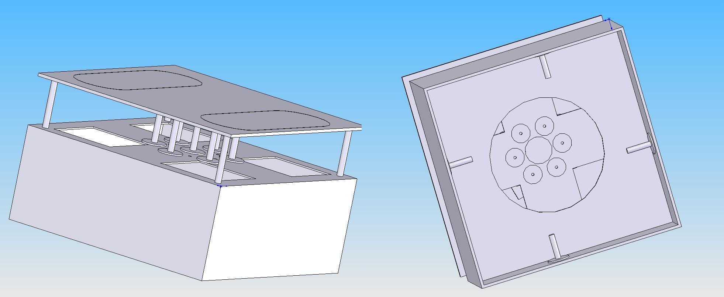
Figure 1: Case Design #1

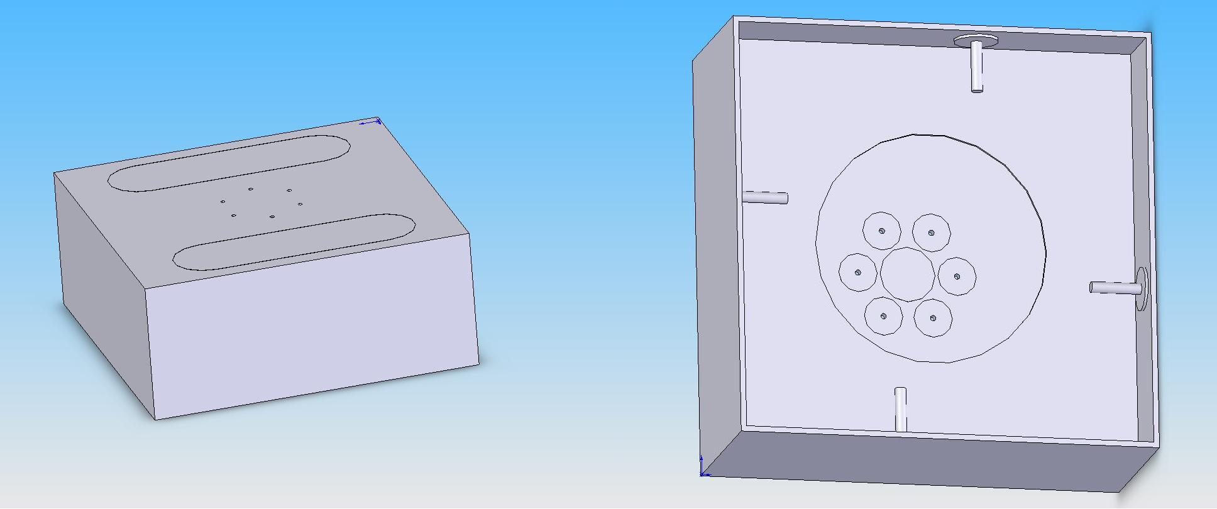
Figure 2: Case Design #2

Each case weighs about 27 lbs. so weight is not a deciding factor. A stress analysis showed that each case has a factor of safety at its weakest point of about 3.5. This is plenty as we do not expect rough terrain or very extreme conditions for this scooter. From figure 4 it can be seen where the high stress concentrations occur in each model. For case #1 the highest stress occurs in the vertical rods between the top two levels. In case #2 the highest stress occurs in the center of the top platform.

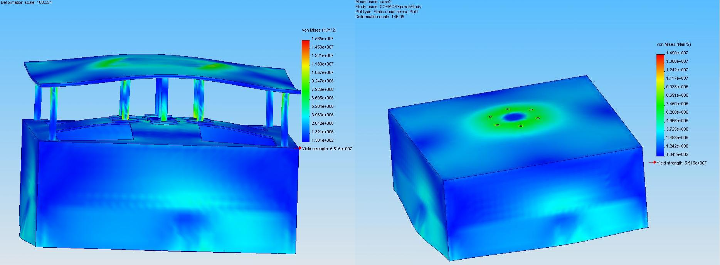
Figure 3: Stress Analysis for Case #1 and #2.

Figure 5 is a picture of case #2 with its top taken off and a possible way to fit all of the electronics in its housing. The battery packs and motor controllers are around the outside of the case while the gyroscope and board are barely visible on the inside. This shows that there is plenty of room in case #2. However, as stated earlier, there may be a heat problem if all of these electronics are packed so closely together.
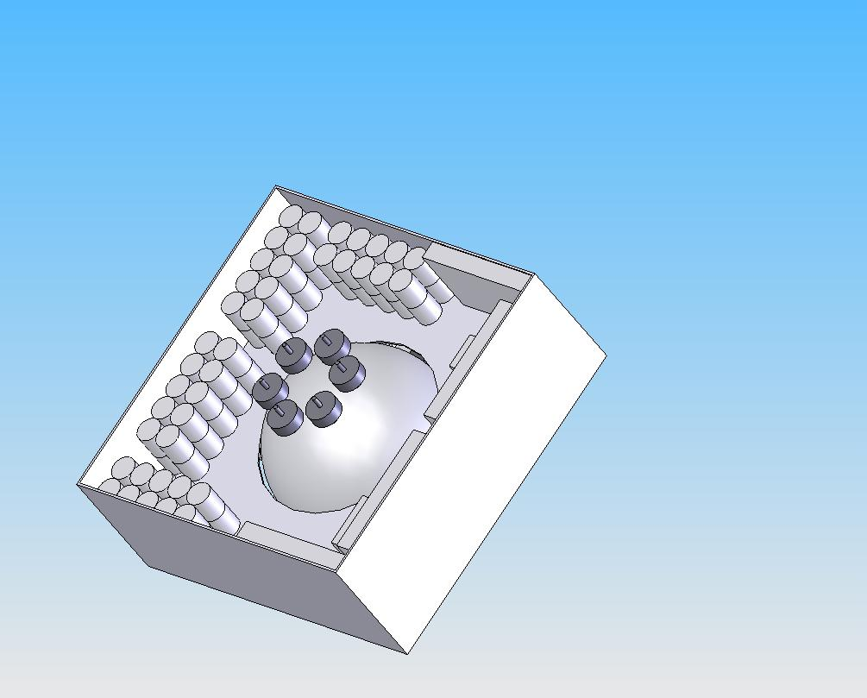
Figure 4: Open Case with Electronics

Analysis

In short, all figures should

- Have a purpose. If they aren’t important enough to refer to in the text, don’t include them.
- Be titled, captioned, and labeled (including axes and units).
- Help readers visualize information that is hard to communicate textually. Use figures to organize data—it will save you time in writing your report.

Example #4: Using Informal Language and Quantitative Descriptions

In these design reports, you are expected to move beyond your role as a student to demonstrate expertise in the area in which you have chosen to work. Some teams will be entering design competitions, where the quality of your work will be judged, at least initially, on the quality of your report. It is therefore essential to begin taking on the role of expert in your writing. This means using forceful, authoritative language, removing references to classes, semesters, or other university-related benchmarks, and backing up all statements with solid evidence.

Below, we have excerpted some examples from the student paper that illustrate the type of writing that is all too common in these reports.

- “At the start of this project, much research was done both on the internet and in the library for anything on two-dimensional inverted pendulums.”

Would you expect an expert in a field to write something so obvious? Experts simply summarize past work, include a citation, and use it as a launching pad for a discussion of why their solution is better, different, etc.

- “The largest drawbacks are that they require a substantial amount of power and must be geared in some fashion in order to be made useful.”

What is “substantial”? What precisely is meant by “geared in some fashion”? Such informality undermines credibility.

- “Additionally, rubber is relatively cheap and more easily accessible than other alternatives.”

Specify what “relatively” means to you. And what is meant by “more easily accessible”?

- “To determine the best fit for our power supply it is important to first understand what is needed.”

The team begins many of the introductory paragraphs in its subsystems discussion with this type of empty phrase. Of course understanding the needs is important. Rather than stating the need determine the needs, open by stating the need and how this need translates into requirements.

- “One nice thing about this system is that the normal force can be known pretty accurately. This is done by measuring the deflection of the spring and multiplying that by the spring constant. Since the wheel is about halfway between the middle of the universal joint and the ball bearing, the normal force between the wheel and sphere will be about twice the force of the spring.”

Words like “nice,” “pretty,” and “about” have little utility in a scientific report, particularly when applied to mathematical concepts such as force. Use equations, calculations, and math to quantify these claims, or don’t make the claims at all.

- “However, after talking to people from Rotomotion, we have been assured it is fully capable to do much more than that, and will be able to store and execute our control software.”

Don’t base decisions on assurances. Base them on data obtained by testing components.

- “Over the break we are going to inspect a sample 7 inch solid rubber sphere.”

What “break”? Such benchmarks mean nothing to an outsider. Instead say, “We plan to inspect…”

