BIOE 301: Bioengineering and World Health Name:______________________

Exam 1: January 30, 2007 Signature:___________________

The exam consists of 9 questions and 2 extra credits on 11 pages. Show all work to receive credit. Clearly organize your work and draw a box around your final answers for calculations. NEATNESS COUNTS! Good Luck!

Problem 1 (12):

Problem 2 (6):

Problem 3 (12):

Problem 4 (10):

Problem 5 (10):

Problem 6 (16):

Problem 7 (12):

Problem 8 (12):

Problem 9 (10):

Extra Credit (2):

Total (100):

1. (12 pts)
Advanced breast cancer has a high mortality. Initial clinical trials indicated that high dose chemotherapy followed by a bone marrow transplant could reduce the mortality rate by as much as 40%.

  - Why did physicians and scientists believe that higher doses of chemotherapy would be more effective for advanced breast cancer? (4pts)

It appeared that women with metastatic breast cancer who received higher doses of chemo responded better. Early phase II trials of very high dose chemo followed by bone marrow transplant (which were not randomized) showed promising results. The idea was that higher doses of chemo would kill all residual breast cancer cells.

  - Why is it necessary to give patients a bone marrow transplant following high dose chemotherapy? What will happen if they do not receive a bone marrow transplant? (4 pts)

Because high dose chemo kills bone marrow cells. The bone marrow is responsible for regenerating cells of the blood, including oxygen providing red blood cells and infection fighting white blood cells. Without bone marrow, a person will rapidly die, so it must be replaced.

  - In the context of this example, discuss how political pressures overwhelmed scientific evidence. How could this be avoided in the future? (4 pts)

In the 1990s, because of the publicity of a very small clinical trial, more than 41,000 patients underwent HDCT+BMT for breast cancer despite a paucity of clinical evidence regarding effectiveness. Patients sued their insurance companies to get coverage and large jury verdicts and legislation forced insurance companies to pay for an unproven procedure.

During this period, it became very difficult to recruit patients to randomized Phase III clinical trials which would determine whether the technique was really effective. These trials took twice as long to complete as planned and delayed findings.

The results of the small positive trial were later shown to be falsified.

This could be prevented in the future by requiring a higher standard of scientific evidence before laws are enacted. Also better controls to review publications regarding clinical trials to prevent scientific fraud are required.

2. (6 pts)
The figure below is from the WHO World Health Report, 2005 and was also included in your text book. It shows that in many parts of the world the rate at which child mortality is reduced has leveled off in recent decades. Provide a reason for why the rate of decline has slowed when compared to the decrease between 1970 and 1980.
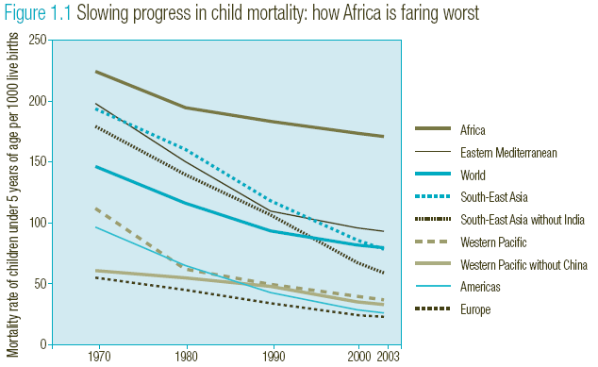

Again, any reasonable answer is acceptable. The ones below were specifically mentioned in the lecture or textbook.

Original speed may have been due to immunization campaigns, which have since stalled
Civil strife or humanitarian crisis often results in a stagnation or increase in the child mortality rate
Drug resistance to typical therapies
Lack of improvements in infrastructure: clean water, health facilities and health care workers, drug availability, etc.

3. (12 pts)
The data in the table below was adapted from the WHO World Health Report, 2005. Based on the provided information for each area/region please:

  - Calculate the total under 5 mortality rates for each region (4 pts)

  - Calculate the under five mortality rate due to neonatal causes for each region (4 pts)

Area/Region | Total under 5 Mortality Rate | per 1000 | Under 5 Mortality rate due to neonatal causes | per 1000
Africa | 0.0396236 | 39.623594 | 0.0103476 | 10.347563
Canada and USA | 0.002176 | 2.1759944 | 0.0012621 | 1.2620768
South East Asia | 0.0171521 | 17.152084 | 0.0076095 | 7.6094912
Europe (Low mortality states) | 0.0011338 | 1.1337868 | 0.0006349 | 0.6349206

  - Calculate what percent of under 5 deaths are due to each of the six causes listed for each region (don’t worry if they don’t sum to 100%). (4 pts)

 | Percentage of total under 5 deaths
Disease | Africa | Canada and USA | South East Asia | Europe (Low mortality states)
Measles | 5.1637853 | 0 | 3.3550489 | 0
Malaria | 18.243858 | 0 | 0.3908795 | 0
Diarrheal Disease | 15.946315 | 0 | 17.980456 | 0
Neonatal Causes | 26.11465 | 58 | 44.364821 | 56
Acute Respiratory Infection | 21.019108 | 2 | 19.218241 | 0
Injuries | 1.7288444 | 10 | 2.3127036 | 8

Area/Region | Under 5 Population (000) | Total # of under 5 deaths (000) | # of under 5 deaths (000) due to:
 |  |  | Measles | Malaria | Diarrheal diseases | Neonatal Causes | Acute Respiratory Diseases | Injuries
Africa | 110,944 | 4,396 | 227 | 802 | 701 | 1,148 | 924 | 76
Canada and USA | 22,978 | 50 | 0 | 0 | 0 | 29 | 1 | 5
South East Asia | 178,987 | 3,070 | 103 | 12 | 552 | 1,362 | 590 | 71
Europe (Low mortality states) | 22,050 | 25 | 0 | 0 | 0 | 14 | 0 | 2

4. (10 pts)

a. On the blank axes below, draw and clearly label two graphs depicting the progression of HIV/AIDS: (4 pts)
CD4+ T Lymphocyte Count
HIV RNA Copies
b. In the area above your 2 curves, place labels showing the duration of the following stages of the illness: (3 pts)
Opportunistic infections
Clinical latency
Acute HIV syndrome
c. On your CD4+ T cell curve, indicate the CD4 levels at which the following infections are most likely to be seen: (3pts)
MAC (Mycobacterium Avium Complex)
Skin infections
Tuberculosis

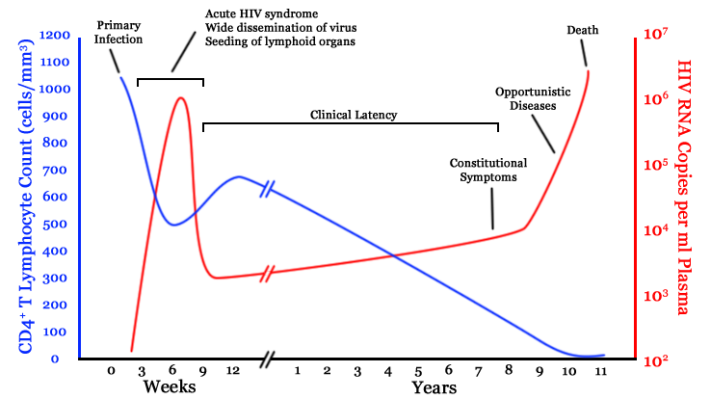

- For the two curves, full credit requires the changes associated with acute HIV syndrome: spike in RNA and dip in CD4 count. Full credit also requires correct overall trends: decreasing CD4 count, increasing RNA copies, and correct labels for the two curves.
- For the illness stage labeling, full credit requires the correct order: Acute HIV syndrome, Clinical latency, Opportunistic diseases.
- For the CD4 levels, full credit requires only the order: Skin, TB, MAC. Students are not required to give exact CD4 levels.

5. (10 pts)
Oh no! You return to Student Health two days after receiving a routine PPD skin test. You have a red bump on your forearm that measures 12 mm in diameter. Every year up until now, your test had been negative.

a. How does the PPD skin test work, and why does a red bump form for individuals infected with TB? (3 pts)

The PPD test injection contains antigens that mimic those on the tuberculosis bacterium (1 point). Your T cells were exposed to antigens on tuberculosis when you first became infected. These sensitized T cells recognize the PPD antigens, and they rush in, forming a red bump at the site of the injection (1 point).

b. Assuming you have no significant health problems, what are the odds that the bacterium will remain in a latent, inactive state for the rest of your life? (2 pts)

90%

c. As we discussed in class, this test is imperfect. Describe one instance in which the PPD skin test fails by giving a false-negative result, and describe another instance in which the test fails by giving a false-positive result. Why does the test fail in each circumstance? (5 pts)

False-negative: listing any of the following receives 1 point:
--People infected with TB that have a weakened immune system (e.g. AIDS patients, those on immunosuppressive therapy, infants, or the malnourished) who cannot mount an effective T cell response.
--People who have very recently been infected with TB: it takes several weeks after infection for your immune system to react to the antigens.

False-postitive: listing any of the following receives 1 point:
--BCG vaccination. This less-than-perfect vaccine, given in many foreign countries, causes your immune system to react to PPD antigens (theoretically preventing TB infection), causing a positive skin test even if you have never been exposed to TB.
--You’ve been treated for TB in the past. Even after successful treatment with antibiotics, your PPD will remain positive for life, whether you have been re-infected or not.

6. (16 pts)
a. Describe the process by which a normal cell in the human body becomes a metastatic tumor. Refer to the diagram below. (6 pts)
1 point each for including any of the following in the correct order, up to 6 points total:
- Clonal expansion/growth/diversification from ONE transformed cell
- Metastatic subclone
- Adhesion to and invasion of basement membrane
- Passage through extracellular matrix
- Penetrating and entering the blood or lymph vessels (AKA intravasation)
- Interaction with/hiding from the host lymphoid cells
- Tumor cell embolus
- Adhesion to the basement membrane
- Penetrating and exiting the blood or lymph vessels (AKA extravasation)
- Metastatic deposit

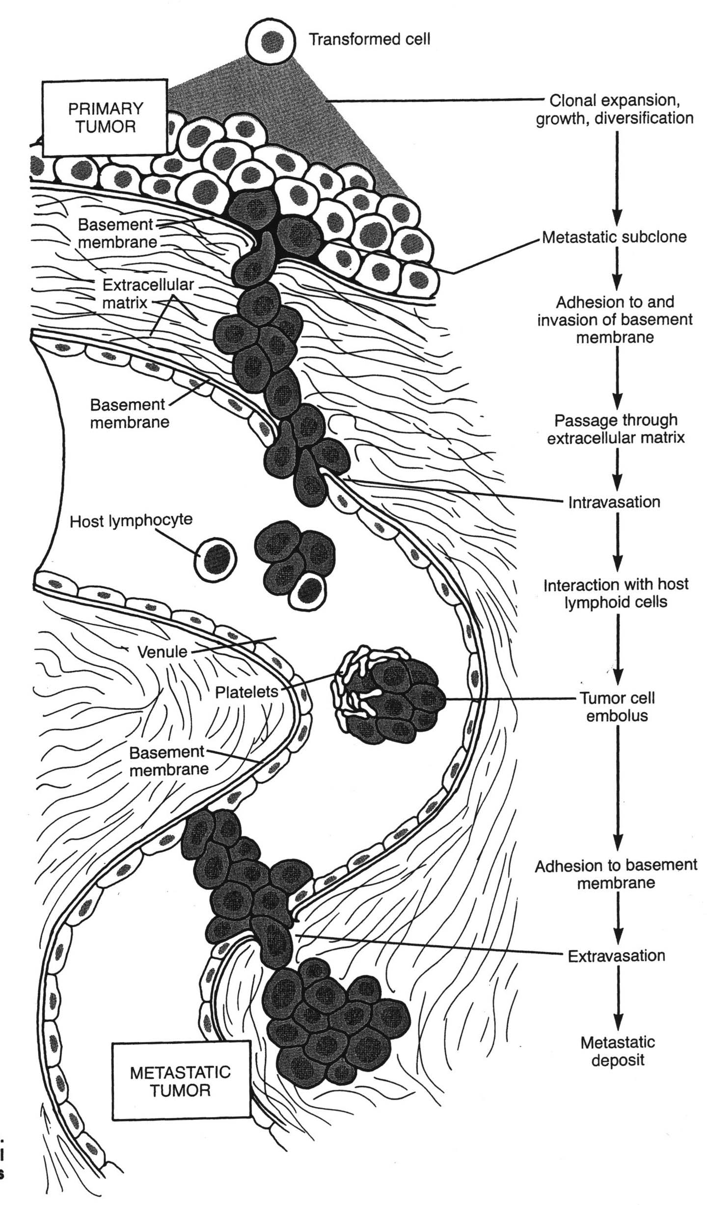

- i) What is the most deadly cancer in women in the U.S.?

Lung cancer (1 point)

ii) What is the most deadly cancer in men in the U.S.?

Lung cancer (1 point)

c. Treatment for most cancers currently consists of three interventions: surgery, radiation, and chemotherapy. Why is surgery not always successful? And why are such terrible side effects associated with radiation and chemotherapy? (4 pts)

Surgery to remove a tumor often misses small metastatic deposits that have already begun to grow elsewhere in the body. (2 points)

Radiation and chemotherapy kill not only malignant tumors, but all rapidly dividing cells, including hair follicles, GI tract epithelium, bone marrow, etc. (2 points)

d. It has recently been shown that several types of infectious diseases can lead to cancer. List two of these infections, along with the type of cancer that they produce. (4 pts)

(1 point for each infectious agent, up to 2, and 1 point for the correctly paired cancer, up to 2)

HPV (human papilloma virus) – cervical cancer
H. pylori (Helicobacter pylori) – stomach cancer
HBV (hepatitis B virus) OR HCV (hepatitis C virus) – liver cancer

Although not discussed in class, credit would also be given for the following:
Epstein-Barr virus—Burkitt lymphoma
HTLV-1—T cell leukemia
HIV—lymphoma, or HIV—Kaposi sarcoma, would be acceptable as well

--no credit given for prostate cancer; the causality has not yet been proven!
7.
Health systems in the US vs. the world (12 pts)

  - Describe 2 differences and 2 similarities in the US and Canadian health systems (in terms of health system management and outcomes) (6 pts)

    - Differences
      - Canada has simpler bureaucracy & administration, significantly simpler
      - Much longer waiting times for procedures
      - Less access to health care in the US vs. universal coverage in Canada
      - Less availability of advanced technology in Canada
      - All costs are born by the Canadian provincial governments versus only a portion of the overall costs are covered by state and federal gov’t
      - Canadians can choose their physicians, in the US there are limitations based insurance coverage
      - Canada spends a lower proportion of their GDP

    - Similarities
      - employers play role in subsidizing premiums or providing coverage
      - Not everyone is covered for all services are covered- especially optical and dental care
      - for-profit care exists in both systems
      - Private insurance is available to cover drug plans and other services
      - Government plays a role in providing health care
      - similar low infant mortality and long life expectancy→ could also be listed as a differences (but lower credit)

  - Technology plays an integral role in the differences between these two countries. (3 pts)

    - List two challenges Canada faces regarding new and advanced technology
      - poor availability of new technologies
      - no way to fund new technology
      - long waiting times for US, MRI and advanced surgical techniques etc.

    - List two challenges newer technologies pose to the US health system (3 pts)
1. increasing costs of advanced technologies directly (ie. hardware costs)
2. changes the population needing health care- sicker people live longer due to these technologies
3. greater disparities in available care—only available to the select few who can afford it

8.
The graph above shows the distribution of national health expenditures by type of service in 1994 and 2004. Note: “Other Health Spending” includes administration and net cost of private health insurance, public health activity, research, and structures and equipment, etc. “Other Personal Health Care” covers dental and other professional health services, durable medical equipment, etc. (12 pts)
  - What area of spending shows the greatest increase during that time span?
Prescription drugs (2 pts)
  - List two reasons for this increased spending (4pts)
    - Use of direct marketing by drug companies
    - New drug development costs
    - Drug company profits
  - During this time period the only significant drop in spending occurs in hospital care. Account for this drop and speculate as to whether the percent of expenditures going toward hospital care is likely to continue to drop over the next 10 years. (6 pts)
    - Major reasons
      - The decline in hospital care costs is due to the shift from conventional insurance coverage for the majority of Americans to manged care that occurred in the mid- 1990’s. Managed care increased efficiency of care, tended to increase ambulatory care which reduced hospital stays. Likewise, increases in preventative care may also have contributed to reduced hospital costs.
      - Hospital care costs have also shifted related to technology allowing more outpatient care such as chemotherapy, and also allowing more minimally invasive treatments that decrease hospital stays
    - Over the next 10 years it is likely that home health care, nursing home care, and prescription drug spending will increase as the baby boomers retire and the elderly population increases significantly. Thus, the percent of expenditures going to hospital care is likely to continue to decrease (note, however that overall costs will continue to increase).
9.
Health care reform (10 pts)

  - Reform of health care in the US appears to show a shift towards universal coverage. Describe how legislation implemented in states like Oregon and Massachusetts are extending coverage. ( 5pts)

i. Fining or requiring employers to provide some level of coverage
ii. Providing tax incentives for individuals to have coverage
iii. Extending state programs to cover more of the population at or below the poverty line
iv. Rationing of health services provided by the state
v. Providing incentives and guidelines to insurance companies to provide affordable rates
vi. Increasing taxes

  - In contrast, the Canadian health care system is shifting toward a two-tier system more similar to that in the US, describe 2 reasons for this shift. (5pts)

    - Long waiting times for surgery and diagnostics
    - Desire for more access to greater technology
    - Physicians want higher pay
    - People are willing to pay higher fees for increased and faster access

Extra Credit: (2 pts)

1. Geoff Preidis volunteers a lot of his time helping low-income people in which country?

Haiti (1 pt)

2. Gwen Hoben mentioned towards the end of her lecture that one way of helping in allocating health resources is to participate in this activity?

Vote (1 pt)

